Mohammad Hasan

Course: CIS 244

Professor: Yanilda Peralta Ramos

May 12, 2025

**Project Title: Dental Clinic Database System**

**1. PROJECT SELECTION**

**Mini World (Dental Clinic):**

In this project, the database for a dental clinic system is being created. Essential components of a dental clinic, such as patient data, dentist schedules, appointments, treatments, bills, and medical histories, will be managed by the system. Reducing manual labor, increasing customer service, and streamlining clinic operations are the objectives.

**2. SYSTEM DESIGN REQUIREMENTS**

**Requirement Gathering:**  
The system will capture data for the following entities:

* Patient: Stores information about patients, including their names, contact details, and emergency contact information.
* Dentist: Stores information about the dentists, including their names, specialties, and available schedule.
* Appointment: Captures details of the patient's scheduled appointments, including date, time, assigned dentist, and treatment.
* Treatment: Includes the name of the treatment, cost, and duration of each procedure provided at the clinic.
* Invoice: Has the billing details for each patient, including total charges, payment status, and date of payment.
* Medical Record: Tracks the treatment history of each patient to ensure the dentist has a comprehensive view of the patient's health and past treatments.

I started by identifying the vital components that are necessary for the Dental Clinic system's operations before developing the database. Managing patients, dentists, appointments, treatments, and invoicing were some of these components. I choose these organizations because they are pertinent to a dental clinic's main functions.

* Patients: I included this entity because a dental clinic’s primary function is to serve patients. The system needs to track each patient's personal information, contact details, and medical history.
* Dentists: A dental clinic is composed of multiple professionals, each with specific specialties. I included the Dentist entity to manage their information, which helps in scheduling appointments based on dentist availability and specialization.
* Appointments: This entity was essential because every patient visit to the clinic involves an appointment. By tracking appointments, the system can schedule and assign patients to dentists based on availability.
* Treatments: Dental clinics provide various treatments. I chose to include a Treatments entity to keep track of which treatments were provided to patients during their appointments.
* Invoices: An Invoice entity was included to manage billing information. After a treatment, an invoice needs to be created, which includes the charges for services provided.
* Medical Record: Tracks the treatment history of each patient to ensure the dentist has a comprehensive view of the patient's health and past treatments.

I chose fields in the characteristics for each entity that would give all the information required for the clinic to function well. For instance, I added PatientID, Name, and DateOfBirth to the Patient entity since these are the most important details that will be required to locate and get in touch with the patient. To keep track of when and where appointments are set, I also entered AppointmentDate, PatientID, and DentistID in the Appointments section. This procedure was directed by an awareness of the practical requirements of a dental office, including scheduling, billing, treatment monitoring, and patient care. The entities and attributes have been selected to represent the essential elements that need to be recorded for effective clinic management and seamless functioning.

**Here is the screenshot:**

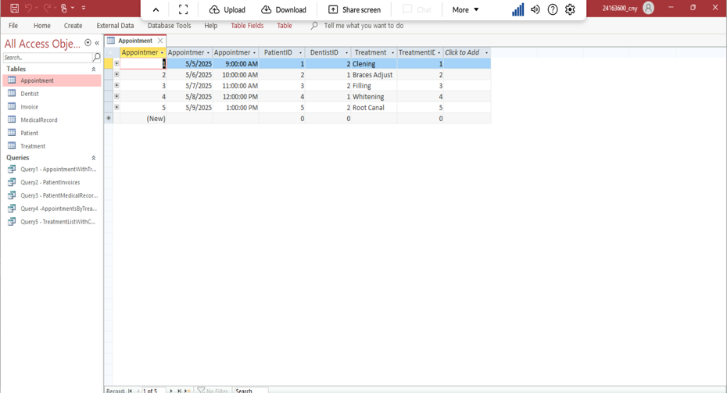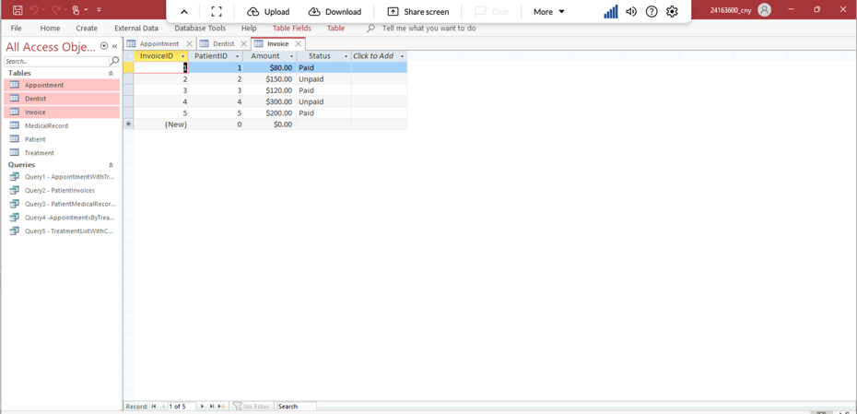

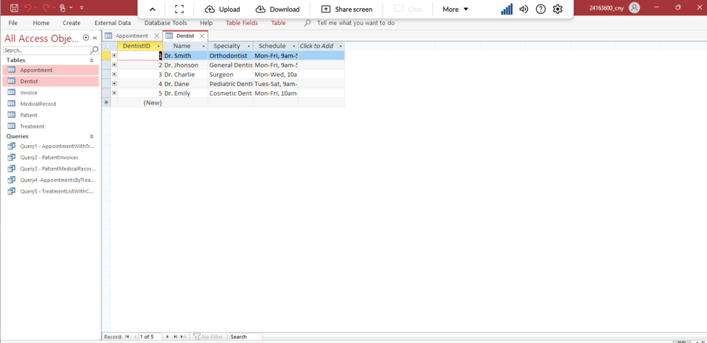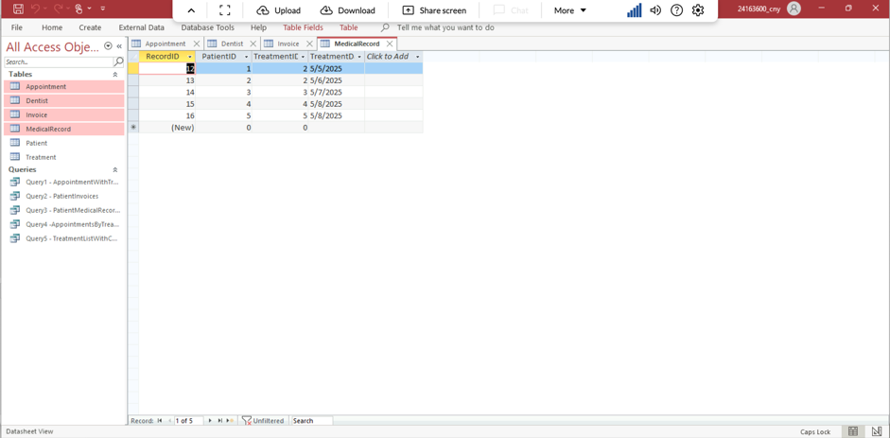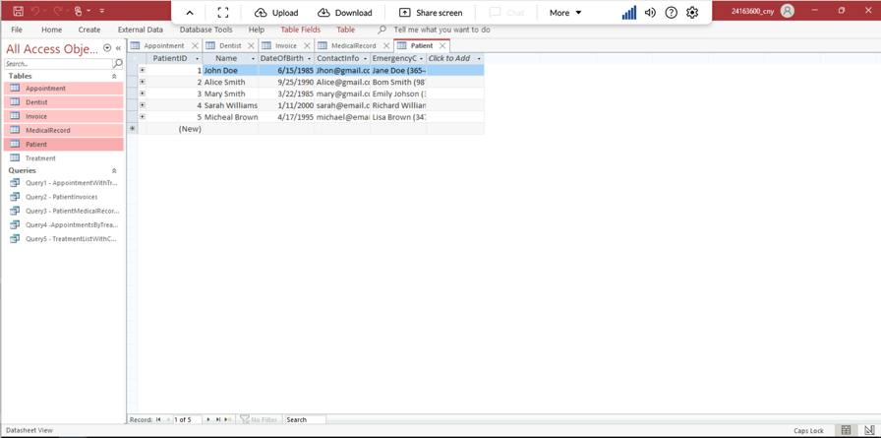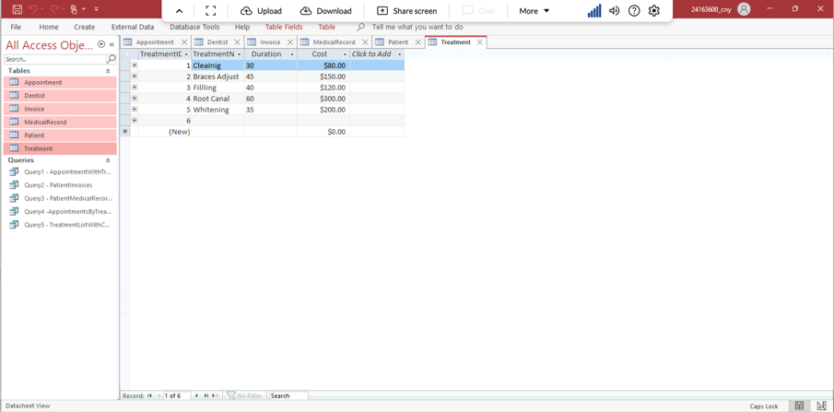

**3. ENTITY-RELATIONSHIP (ER) DIAGRAMS**

**• Simple ER Diagram (Access or Draw.io) (Screenshot):**

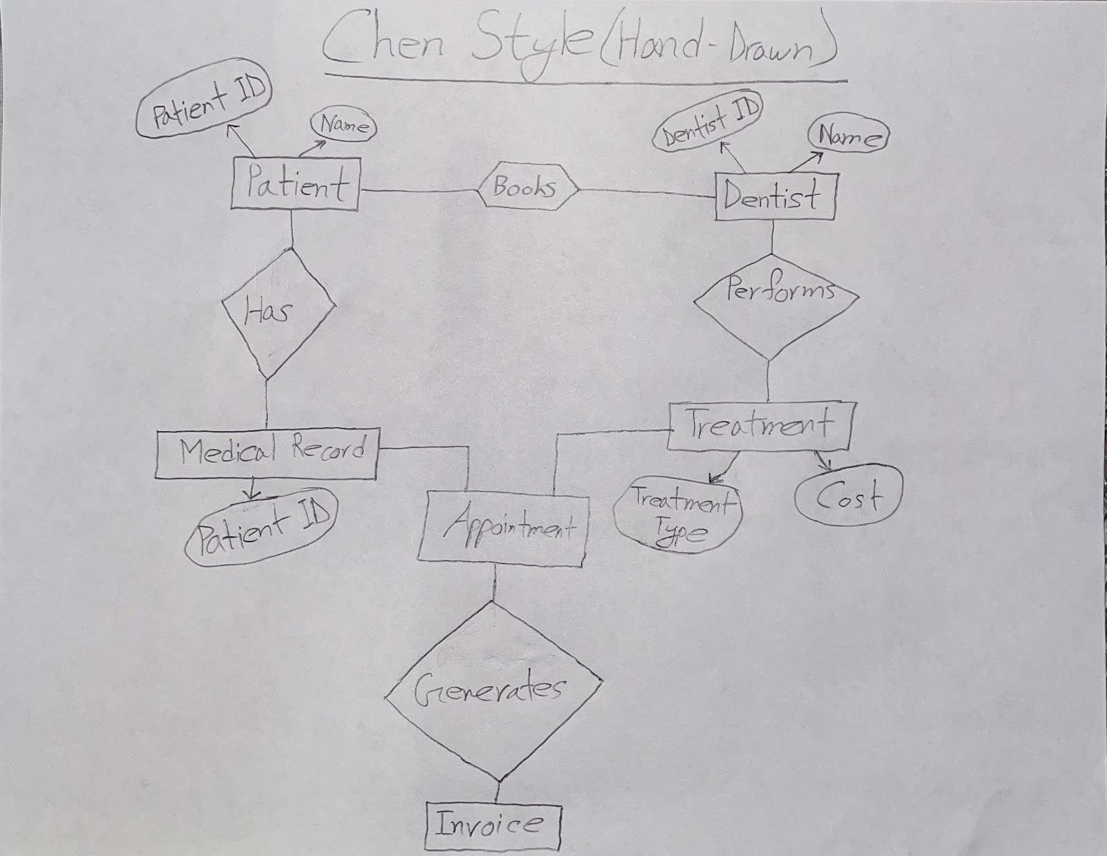

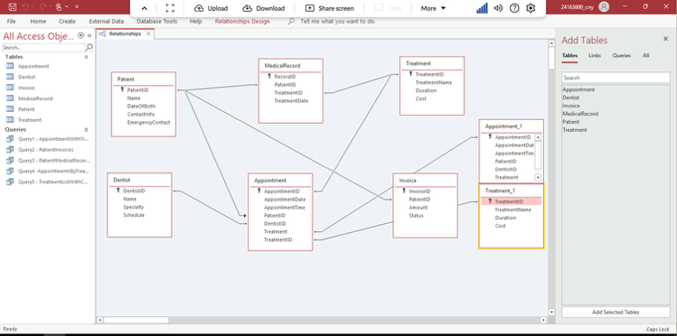

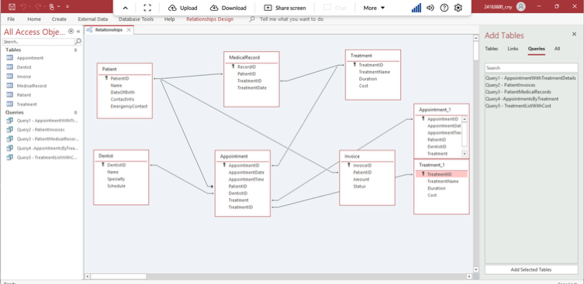

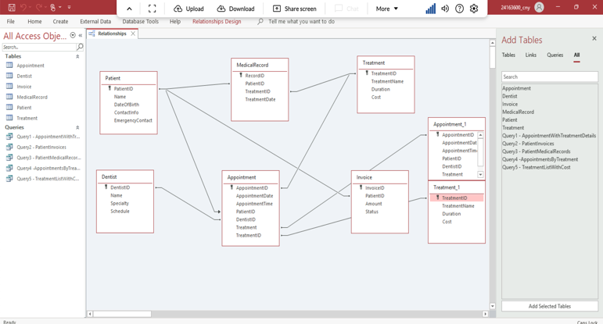

**4. DATABASE CREATION:**

**Development in Access:**





**- Export to MySQL and SQL Script:**

**Here is the all the screenshot about MYSQL and SQL Script below:**

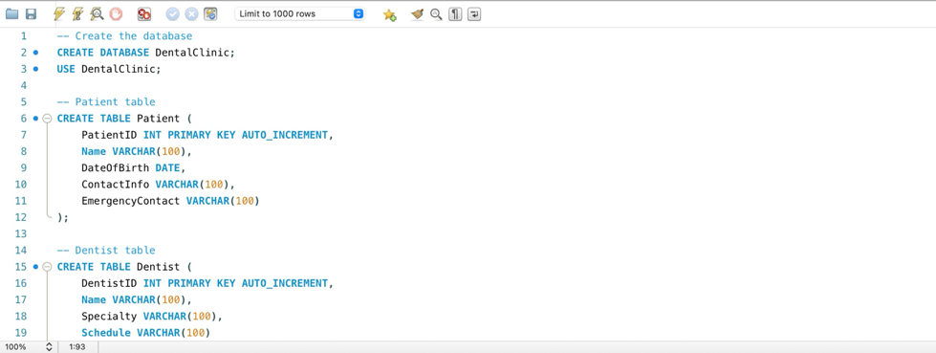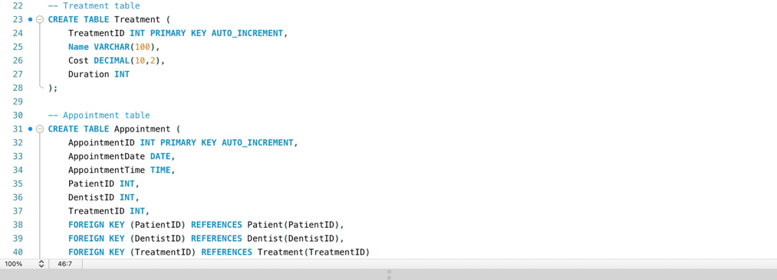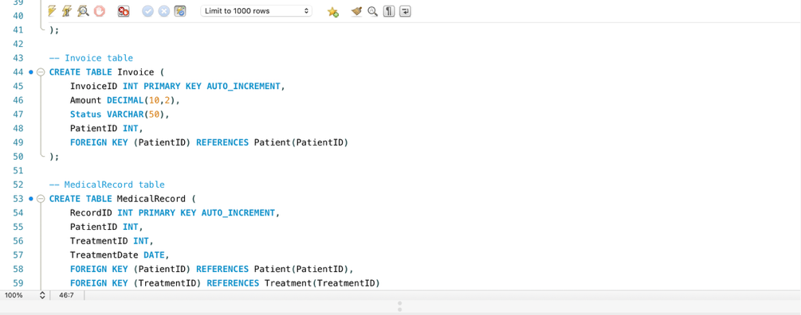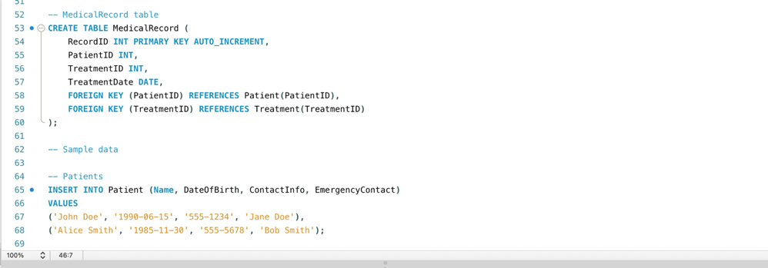

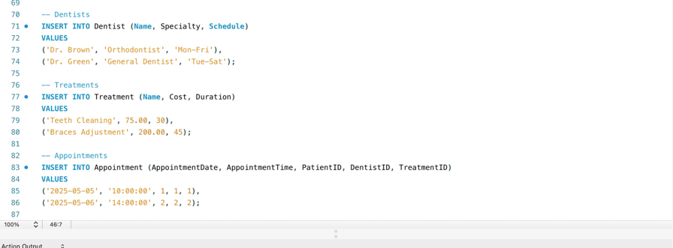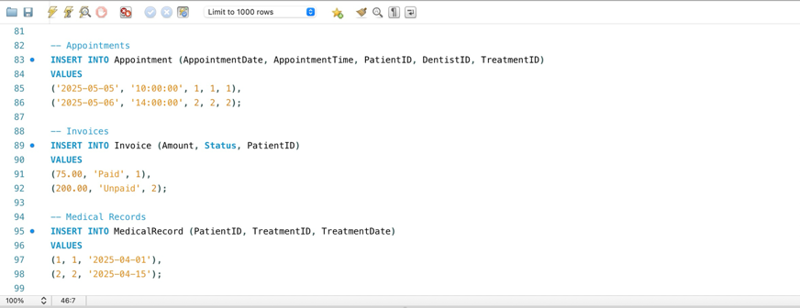

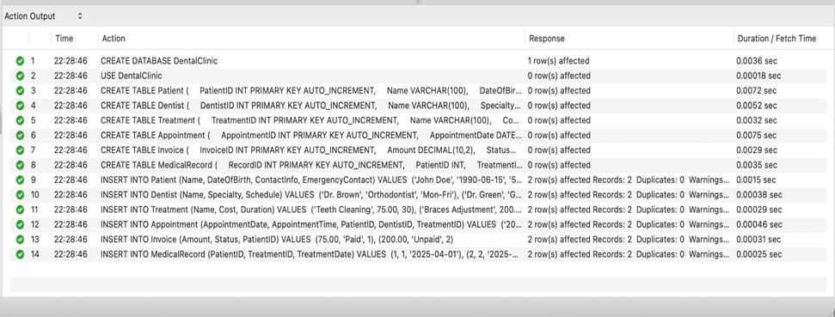

**- Project Summary**

This project aimed to create and deploy a relational database for a practical application. I decided to model a dental clinic management system, which is concerned with scheduling appointments, keeping track of patients, treating patients, billing, and dentists.

My initial plan was to collect actual data from a nearby clinic in order to develop a database model that was more accurate and realistic. I went to a neighboring neighborhood clinic and the Fordham dentistry clinic to get sample data or basic schema information for my coursework. But both clinics couldn't exchange any information because of stringent privacy and confidentiality laws regarding patient data. Consequently, I drew on my observations and basic understanding of healthcare operations to develop a fictitious dental clinic database.

I started by identifying the main entities and their relationships in a hand-drawn ER diagram using Chen notation. For a better presentation, I then used Draw.io to build a digital version. I created the database tables in Microsoft Access after completing the ERD, adding five to ten sample records to each table. Additionally, I created SQL scripts that used CREATE TABLE commands to define the similar structure for MySQL.

**- Challenges Faced**

The first significant obstacle I encountered was that privacy issues prevented me from gathering actual data from a dental facility. I overcome this by building my schema using logical assumptions and analyzing common fields found in healthcare databases. Modeling many-to-many relationships—for example, a patient with several sessions, each involving a different treatment—was another difficulty. To handle these connections appropriately, I fixed this by introducing junction tables, such as an Appointment, Treatment table. It also required some experience to learn how to organize the SQL scripts for MySQL, define foreign keys, and select appropriate data types. To finish the scripts accurately, I used the resources provided in class and my own creativity.

I learned how to convert real-world scenarios into data models and then use those models in relational databases through this project. I discovered how to use best practices and critical thinking to mimic a realistic and functional system, despite the limits I encountered with real data. My knowledge of database design, ER modeling, and SQL scripting has increased because of the experience.